# Data Types in C

A data type specifies the type of data that a variable can store such as integer, floating, character etc.

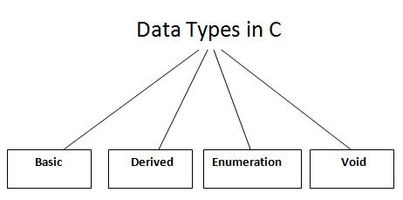

There are 4 types of data types in C language.

|  |  |
| --- | --- |
| **Types** | **Data Types** |
| Basic Data Type | int, char, float, double |
| Derived Data Type | array, pointer, structure, union |
| Enumeration Data Type | enum |
| Void Data Type | void |

## Basic Data Types

The basic data types are integer-based and floating-point based. C language supports both signed and unsigned literals.

The memory size of basic data types may change according to 32 or 64 bit operating system.

Let's see the basic data types. It size is given according to 32 bit OS.

|  |  |  |
| --- | --- | --- |
| **Data Types** | **Memory Size** | **Range** |
| **char** | 1 byte | −128 to 127 |
| signed char | 1 byte | −128 to 127 |
| unsigned char | 1 byte | 0 to 127 |
| **short** | 2 byte | −32,768 to 32,767 |
| signed short | 2 byte | −32,768 to 32,767 |
| unsigned short | 2 byte | 0 to 32,767 |
| **int** | 2 byte | −32,768 to 32,767 |
| signed int | 2 byte | −32,768 to 32,767 |
| unsigned int | 2 byte | 0 to 32,767 |
| **short int** | 2 byte | −32,768 to 32,767 |
| signed short int | 2 byte | −32,768 to 32,767 |
| unsigned short int | 2 byte | 0 to 32,767 |
| **long int** | 4 byte |  |
| signed long int | 4 byte |  |
| unsigned long int | 4 byte |  |
| **float** | 4 byte |  |
| **double** | 8 byte |  |
| **long double** | 10 byte |  |